# 5.5 Amplitude and Period of the Sine and Cosine Functions

## Amplitude

We have seen how the graphs of both the sine function, $y=\sin{θ}$ and the cosine function $y=\cos{θ}$, oscillate between $-1$ and $+1$. That is, the heights oscillate between –1 and 1.

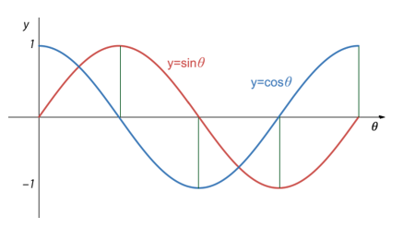

The height from the horizontal axis to the peak (or through) of a sine or cosine function is called

the **amplitude** of the function. Each of the curves $y=\sin{θ}$ and $y=\cos{θ}$ has amplitude 1.

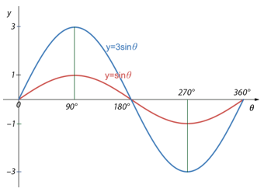

If we were to multiply the sine function $y=\sin{θ}$ 
by $3$, getting $y=3sin{θ}$,  
each of the sine values would be multiplied by 3 making each value 3 times what it was. Each height would be tripled.  
The amplitude of $y=3sin{θ}$ is 3.

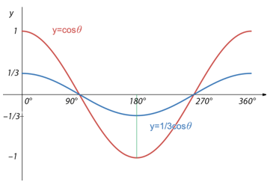

If we were to multiply the cosine function $y=cos θ$ by $1/3$, getting $y=1/3cos{θ}$,  
each of the cosine values would be multiplied by 1/3 making each value 1/3 of what it was. Each height of $y=cos⁡θ$ would be 1/3 of what it was.  
The amplitude of $y=1/3cos{θ}$ is 1/3.

## THE AMPLITUDE OF $y=Asinθ$ AND $y=Acosθ$

Suppose $A$ represents a positive number. Then the **amplitude** of both $y=Asinθ$ and $y=Acosθ$ is $A$ and it represents height from the horizontal axis to the peak of the curve.

Examples

The amplitude of $y=5/8sinθ$ is 5/8. This means that the peak of the curve is 5/8 of a unit above the horizontal axis.

The amplitude of $y=3sinθ$ is 3. This means that the peak of the curve is 3 units above the horizontal axis.

## Period

Both the sine function and cosine function, $y=sinθ$ and $y=cosθ,$ go through exactly one cycle from 0° to 360°. The **period** of the sine function and cosine functions, $y=sinθ$ and $y=cosθ,$ is the “time” required for one complete cycle.

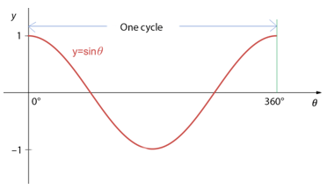 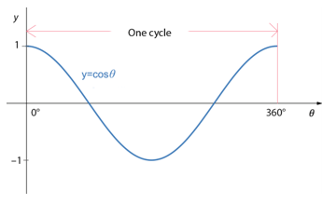

An interesting thing happens to the curves $y=sinθ$ and $y=cosθ$ when the angle $θ$ is multiplied by some positive number, $B.$ If the number $B$ is greater that 1, the number of cycles on 0° to 360° increases for both $y=sinθ$ and $y=cosθ$. That is, the peaks of the curve are closer together, meaning their periods decrease. If the number $B$ is strictly between 0 and 1, the peaks of the curve are farther apart, meaning their periods increase.

## THE PERIOD OF $y=sin\left(Bθ\right)$ AND $y=cos\left(Bθ\right)$

Suppose $B$ represents a positive number. Then the **period** of both $y=sin\left(Bθ\right)$ and $y=cos\left(Bθ\right)$ is $\frac{360°}{B}.$ As B gets bigger, $\frac{360°}{B}$ gets smaller and the period increases.

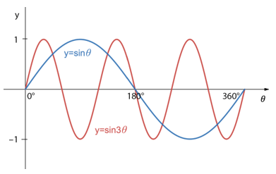

If we were to multiply the angle in the sine function $y=\sin{θ}$ by $3$, getting $y=\sin{3θ}$, each of the angle’s values would be multiplied by 3 making each value 3 times what it was. Each angle would be tripled and there would be 3 cycles in the interval 0° to 360°.  
The period of $y=\sin{3θ}$ is $\frac{360°}{3}=120°$.  
The period of $y=\sin{3θ}$ is smaller than that of $y=\sin{θ}$.

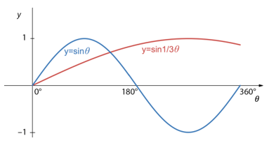

If we were to multiply the angle in the sine function $y=\sin{θ}$ by $1/3$, getting $y=sin\left(\frac{1}{3}θ\right).$ Each of the angle’s values would be multiplied by 1/3 making each value 1/3 what it was and there would be only 1/3 of a cycle in the interval 0° to 360°.  
The period of $y=sin\left(\frac{1}{3}θ\right)$ 
 is $\frac{360°}{1/3}= 360°× 3$ = $1080°$.  
The period of $y=sin\left(\frac{1}{3}θ\right)$ 
 is greater than that of $y=\sin{θ}.$

## Using Technology

We can use technology to help us construct the graph of a sine or cosine function.

Go to www.wolframalpha.com.

Plot two complete cycles of $y=6sin{2θ}$ from 0° to 360°.

Example (1)

Type plot y = 6sin2x, x = 0..360 degrees in the entry field.

WolframAlpha tells you what it thinks you entered, then produces the graph.

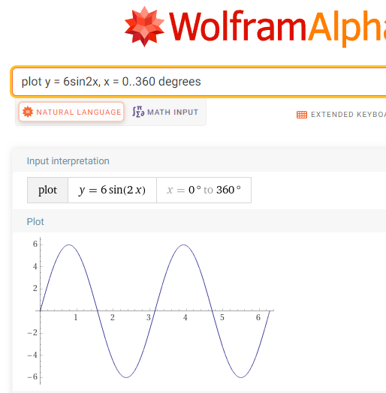

You can see that WolframAlpha has plotted two complete cycles from 0° to 360° with amplitude 6.

Find the period of $y=6sin{8θ}$.

Example (2)

We just need to evaluate $\frac{360°}{B}$ with $B=8$.

$\frac{360°}{8}=45°$

The period of $y=6sin{8θ}$ is $45°$

The graph of $y=6sin{8θ }$ helps us visualize this 45° period. You can see that the peaks differ by 45°.

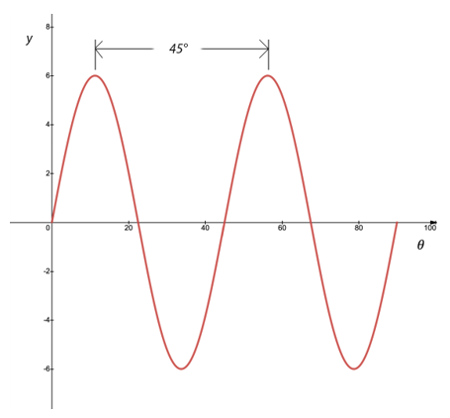

## EXAMPLES

1. Write the equation of each graph.
2. 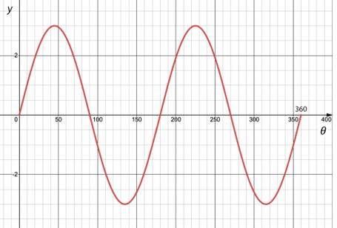 ANS: $y=3sin⁡(2x)$
3. 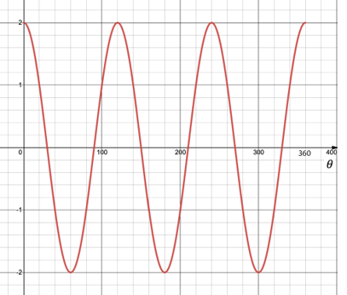 ANS: $y=2cos(3x)$
4. 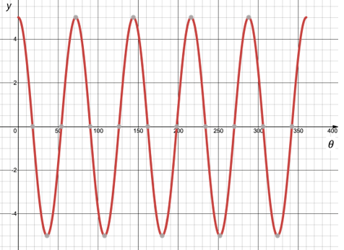 ANS: $y=5cos⁡(5x)$
5. 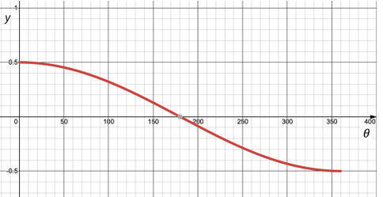 ANS: $y=7cos⁡(x)$
6. How many complete cycles are there in the graph of $y=4cos⁡(3θ)$ from 0° to 360°? What is the period and amplitude of this function?

ANS: 3 complete cycles. Period is $\frac{360°}{3}=120°.$ Amplitude is 4.

1. How many complete cycles are there in the graph of $y=5sin⁡(\frac{4}{5}θ)$ from 0° to 360°? What is the period and amplitude of this function of

ANS: $\frac{4}{5}$ of a complete cycle. Period is $\frac{360°}{4/5}=360°× \frac{5}{4}=450°$. Amplitude is 5.

1. Write the equation of a sine curve that has amplitude 15 and period 50°. You need to specify both $A and B$ in $y=Asin\left(Bθ\right)$. Keep in mind that the period of this function is $\frac{360°}{B}$.

ANS: $y=15sin\left(7.2θ\right)$, where $\frac{360°}{ B}=50°→B= \frac{360°}{ 50°}=7.2$

1. Write the equation of a cosine curve that has amplitude 100 and period 12°. You need to specify both $A and B$ in $y=Acos\left(Bθ\right)$. Keep in mind that the period of this function is $\frac{360°}{B}$.

ANS: $y=100cos\left(30θ\right)$, where $\frac{360°}{ B}=12°→B= \frac{360°}{ 12°}=30$

1. Write the equation of a cosine function that has amplitude 3 and makes two complete cycles from 0° to 180°.

ANS: $y=3cos⁡(4θ)$ We need to specify both $A and B$ in $y=Acos\left(Bθ\right)$. Since the amplitude is 3 $, A=3.$ Since the curve makes two complete cycles from 0° to 180°, it must make 4 complete cycles from 0° to 360°. So, $B=4.$

1. Write the equation of a sine function that has amplitude 4 and makes three complete cycles from 0° to 90°.

ANS: $y=4sin⁡(12θ)$ We need to specify both $A and B$ in $y=Acos\left(Bθ\right)$. Since the amplitude is 4 $, A=4.$ Since the curve makes three complete cycles from 0° to 90°, it must make 12 complete cycles from 0° to 360°. So, $B=12$.

## NOTE TO THE INSTRUCTOR

First, consider presenting the **amplitude** of the sine and cosine function.

Ask what would happen if we multiplied $y=\sin{θ}$ by 4.

If we were to multiply the sine function $y=\sin{θ}$ by $4$, getting $y=4sin{θ}$, each of the sine values would be multiplied by 4 making each value 4 times what it was. Each height would be quadrupled. The amplitude of $y=4sin{θ}$ is 4.

Now discuss what would happen if we multiplied $y=\sin{θ}$ by 1/4.

If we were to multiply the sine function $y=sinθ$ by $\frac{1}{4}$, getting $y=\frac{1}{4}sin{θ}$, each of the sine values would be multiplied by $\frac{1}{4}$, making each value $\frac{1}{4}$ of what it was. Each height of $y=sin θ$ would be $\frac{1}{4}$ of what it was in $y=\sin{θ}$. The amplitude of $y=\frac{1}{4}sin{θ}$ is $\frac{1}{4}$.

To compare the graphs, use [WolframAlpha](http://www.wolframalpha.com/) or [Desmos](https://www.desmos.com/calculator) to construct the graphs of

$y=\sin{θ}$, $y=4sin{θ}$, and $y=\frac{1}{4}sin{θ}$ all on the same coordinate system.

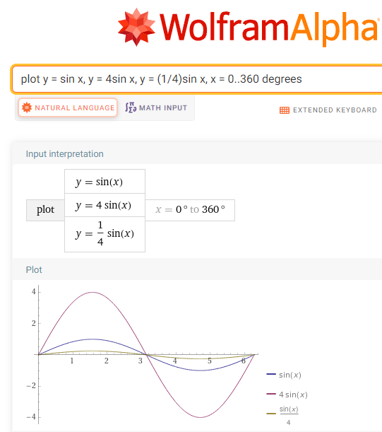

Now present the **period** of the sine and cosine function.

Suppose $B$ represents a positive number. Then the period of both $y=sin\left(Bθ\right)$ and $y=cos\left(Bθ\right)$ is $\frac{360°}{B}.$ As B gets bigger, $\frac{360°}{B}$ gets smaller and the period increases.

Ask what would happen if we were to multiply the angle $θ$ by $4.$

If we were to multiply the angle in the sine function $y=\sin{θ}$ by $4$, getting $y=\sin{4θ}$, each of the angle’s values would be multiplied by 4 making each value 4 times what it was. Each angle would be quadrupled and there would be 4 cycles in the interval 0° to 360°. The period of $y=\sin{4θ}$ is $\frac{360°}{4}=90°$. The period of $y=\sin{4θ}$ is smaller than that of $y=\sin{θ}$.

Ask what would happen if we were to multiply the angle $θ$ is multiplied by $1/4.$

If we were to multiply the angle in the sine function $y=\sin{θ}$ by $1/4$, getting $y=sin\left(\frac{1}{4}θ\right).$ Each of the angle’s values would be multiplied by 1/4 making each value 1/4 what it was and there would be only 1/4 of a cycle in the interval 0° to 360°. The period of $y=sin\left(\frac{1}{4}θ\right)$ is $\frac{360°}{1/4}= 360°× 4$ = $1440°$. The period of $y=sin\left(\frac{1}{4}θ\right)$ is greater than that of $y=\sin{θ}.$

For comparison, you could use WolframAlpha or Desmos to construct the graph of each of these functions on the same coordinate system.

[5-5_amplitude_and_period_of_sine_and_cosine_functions.docx](https://oer4cte.org/math4gamedevelopers/teacher/5-5_amplitude_and_period_of_sine_and_cosine_functions.docx), attributed to Denny Burzynski (author) and Downey Unified School District (publisher) is licensed under CC BY-NC 4.0. To view a copy of this license, visit https://creativecommons.org/licenses/by-nc/4.0